Hades de L’Iton Wins Prix V and B at Craon

September 8, 2025 Harness Trots France

Hades de L’Iton (8g Un Mec d’Heripre-Regence de L’Iton-Elvis de Rosignol) impressively took the Prix V and B at Crain (Gr III, Trophee Vert Final, purse 80,000€, 2775meters distance handicap,15 starters ages 6-10) with trainer/owner Antonin Andre driving. The now 16 time winner in 67 starts has earned 298,905€. The 22/1 Jo Jo Toons (6g United Back-Tata Marguerite-Indy de Vive) ended second for trainer/driver Maxime Bezier and proprietor A.P. Bezier. Joyce Delto (5f Scipion du Goutier) at 6.3/1 was third for driver/trainer Aymeric Thomas and Ecurie Delto. Grace du Digeon (9f Seduissant Foutou) overcame a 25 meter handicap to be fourth with Eric Raffin handling the Charles Dreux trainer and owned mare.
Replay https://www.letrot.com/courses/2025-09-08/5304/1
Hades de L’Iton 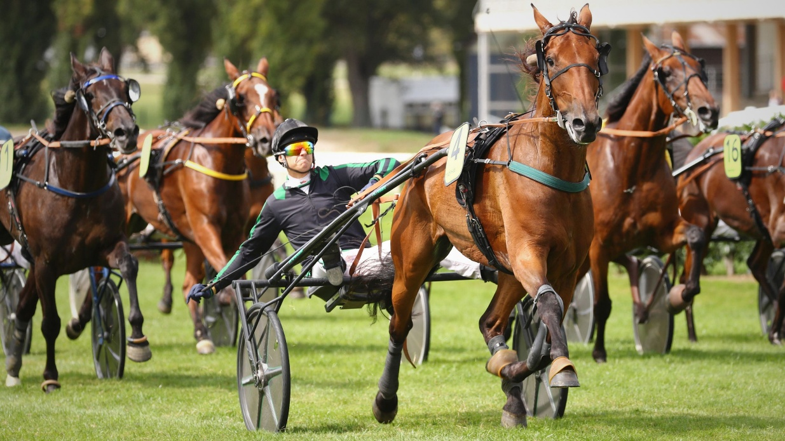
The final Trophee Vert point standings follow:


Hidalgo des Noes ended unplaced in the Craon finale.

Craon, Trotteur Francais files/photos
Thomas H. Hicks

