Kincsem Park Hosts Major Stakes
May 10, 2025 Harness Trots Hungary
Kincsem Park Budapest hosted three major stakes this weekend, each with purses exceeding 1 million HUF. The first was the Otto Varsanyi Memorial (purse 1,200,000HUF, 1800 meters autostart, eight starters) with 1.8/1 odds favorite Daytona Spav (6f Maharajah-Tenerezza Bigi-Nad Al Sheba) a nose winner timed in 1.16.2kr for trainer/driver Veljko Mazsity. This was her second 2025 win in three starts and her 17th win in 24 starts in HU. She was bred in Italy by Sabrina Pedone. Second was 13.4/1 odds Fitzgerald Treb (4f Ringostarr Treb-Ivory Roc-Ganymede) from post one with Marko Slavic the trainer/driver. This mare was also bred in Italy by Enrico Tuci. Third was 7/1 odds Ferragni Dvs (4f Moses Rob-Sabiilla TRGF-Varenne), another Italian bred, with Joze Sagaj up for trainer Zvonko Osterc followed by 11.3/1 Eternal Flame (5m Maximus Lindy-Rubon Lady-Wall Street Banker) with trainer Andor Angyal aboard.
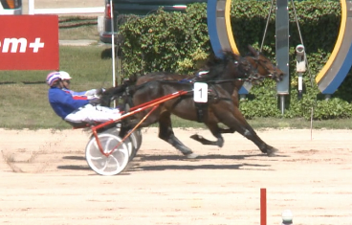 Daytona Spav (2) inside
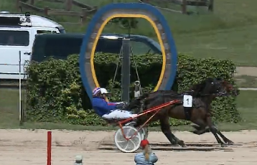
In the Laszlo Ferge Memorial (purse 3,000,000Huf, 1960 meters distance handicap, volt start, HU bred three year olds) the 2.9/1 odds Giovanni Fling (3g Chelsea Boko-Veronica Fling-Racino) scored for trainer/driver Veljko Mazsity and owner Hico, a double for this team after winning earlier with Daytona Spav. This was the winners’ second 2025 win from three starts, also career records. Race time was 1.19.9kr. The 5.5/1 odds Grace Kelly (3f Chelsea Boko-Elegant Lady-Mill H) was second for trainer/driver Laszlo Kolozsi. Both of these were bred in HU by Kabala Menes Kft of Radihaza. The 18.4/1 odds God Save The Queen (3f Unno del Duomo-Urania RG-Racino) with Joze Sagaj driving for Andor Angyal the trainer. Horse and Houses Kft bred this trotter.
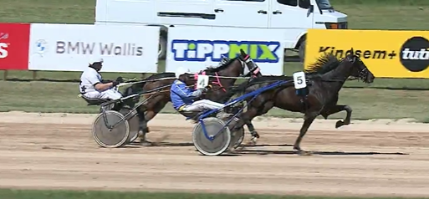 Giovanni Fling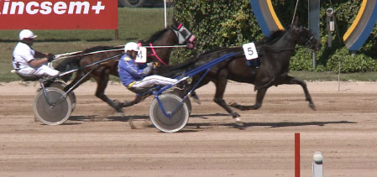
Finally was the classic Dr. Tamas Borostyankoy Memorial (purse 2,000,000Huf, 2560 meters distance handicap volt start, eight starter ages 4-8) and the 8.5/1 odds El Valle Sagrado (6g Nuncio-Urubamba-Maharajah) scored in 1.17.3kr for trainer/driver Attila Budai. This was the winners’ third win this year in six starts and his ninth career win in 36 starts in HU. He was bred in Sweden by legendary Menhammar AB. The 20 meter handicapped and 1.9/1 odds favorite Freya T Boko (4f Campo Bahia-Jasmine F Boko-Trixton) was second a neck back for driver Goran Zolnaji and trainer Adrian Burany. Dolomit Boy (6m Maximus Lindy-Titan Lady-Ata Star L) was third at 22.1/1 odds driven by Istvan Papp for Prolongo III and trainer Bernadett Balogh. The Prolongo/Balogh team were fourth with 22/1 odds Palace Bo (6m Muscle Hill-Jasmina-Abano As) driven by Lajos Marton.
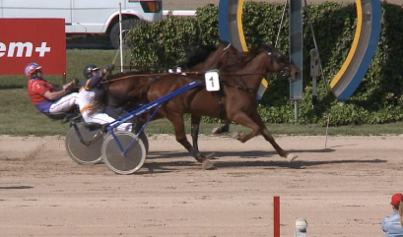El Valle Sagrado 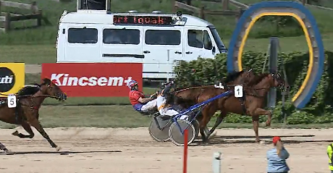 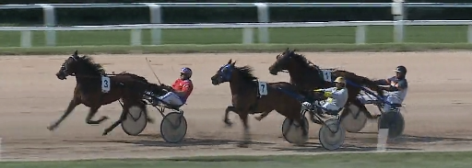
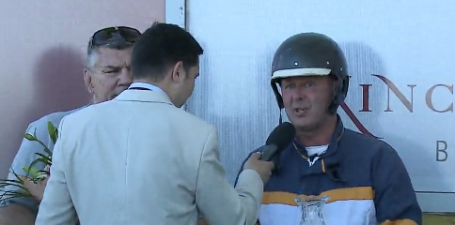Attila Budai
Kincsem Park files/photos
Thomas H. Hicks

