Je Reve du Bois Wins GNT Leg 4
April 23, 2025 Harness Trots France
Today at Maure-de-Bretagne was held the fourth leg of the prestigious Grand National du Trot series. 16 trotteurs (ages 5-10) started in this Gr. III event for a 90,000€ purse that was raced over 2850 meters voltstart. Timed in 1.13.3kr the 33/1 odds Je Reve du Bois (6g Reve de Beylev-Ballerine du Bois) rallied to victory with Anthony Barrier aboard the Charles Marcel Bruneau trainee for owner Vincvent Maure-Martin. The winner recorded his eighth career win in 39 starts now for 239,315€ earned. Ibiza Bella (7f Bold Eagle-Ursula Bella-Goetmals Wood) was second at 6.3/1 odds driven by Antoine Wiels for trainer/owner J.P. Marmion. Janzibar (6g Dollar Macker) landed third at 4.4/1 driven by Alexandre Abrivard for owner Jean Pierre Barjon and trainer L.C. Abrivard. Jongleuse de Lune (6f Cash And Go) was fourth at 12/1 for Paul Philippe Ploquin aboard with fifth money to 15/1 odds Gamin des Isles (9gf Rieussec) for driver Matthieu Abrivard.
Je Reve du Bois in GNT leg 4
Je Reve du Bois
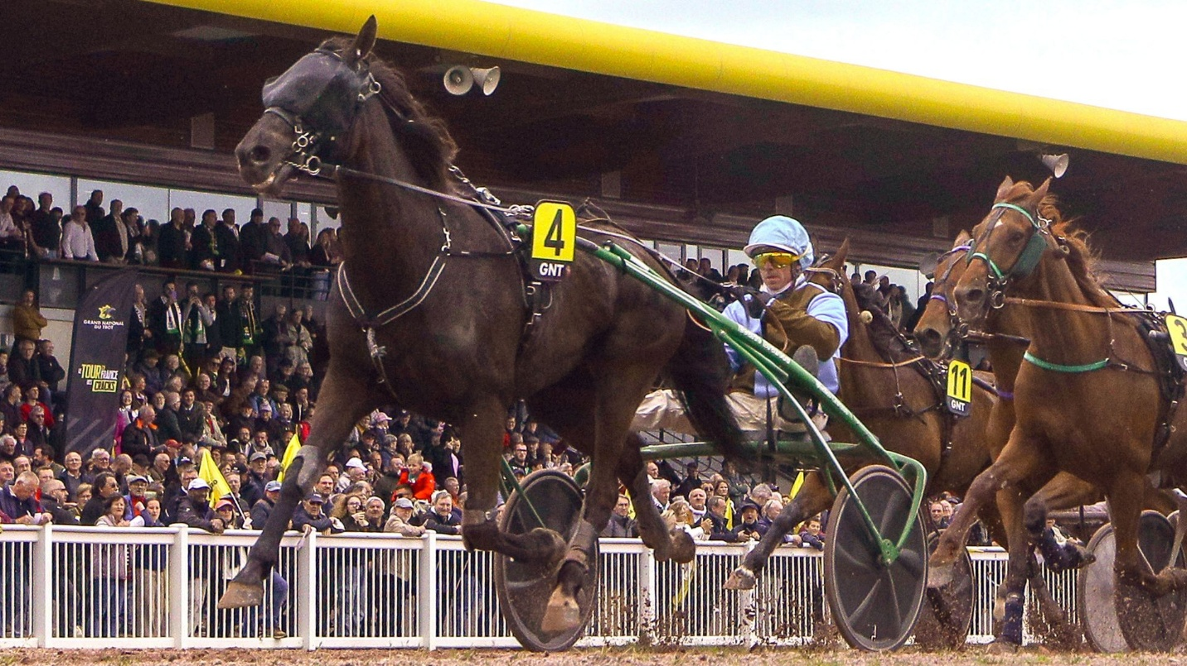
Replay https://www.letrot.com/courses/2025-04-23/3507/1
Coming up next on Sunday April 27 will the next Trophee Vert stop. The 50,000€ purse Prix du Groupe Pigeon will be raced over 3225 meters distance handicap. Engaged are the 50-meter handicapped Grace du Digeon (winner of last Trophee Vert leg), Hidalgo des Noes
and Greco Bello.

Yesterday at Paris-Vincennes the sharp Frank Gio (4m Face Time Bourbon-Zarina Gio) was on hand for a workout to prep for a May 10th stakes test at Caen. The seven time winner in 10 starts in France has earned 727,400€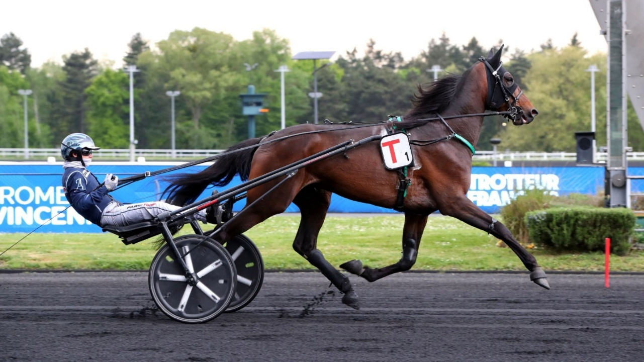Frank Gio
Trotteur Francais, Maure-de-Bretagne files/photos
Thomas H. Hicks

