Alrajah One Tunes Up in Napoli

April 21, 2025 Harness Trots Italy.
Veteran classmaster Alrajah One (9m Maharajah-Matiu’) continued his comeback this day in the Premio Trofeo Gianni Campisi Invitational (purse 17,600€, 1600 meters autostart) at Napoli Agnana timed in 1.10.6kr. Off at 1.95/1 odds the favorite was driven by Vincenzo Luongoi and he moved three wide past pacesetter Usain Toll to score easily. Alrajah One sports 18 career victories for 1,479,639€. He was preparing for the May 4th 76th renewal of the Gr. I Grand Premio Lotteria that carries a 715,000€ purse and is raced over 1600 meters autostart. This race will engage many of the top open class trotteurs in Europe.

In today’s event 29.8/1 odds Condor Pasa Gar (7m Readly Express-Lorin) was second for Giorgio D’Alessanbdro Jr. followed by third finishing 32.1/1 Zefiro d’Ete (10, Mago d’Amore-Isotta Fraschini) with Crescenzo Maione up. Edy Girifalco Gio (5m Victor Gio-Mururoa As) landed fourth at 10.3/1 for Roberto Vecchione with 2.1/1 odds second choice Usain Toll (9g Googoo Gaagaa-Cotton Waste) fading to fifth handled by Gennaro Amitrano.
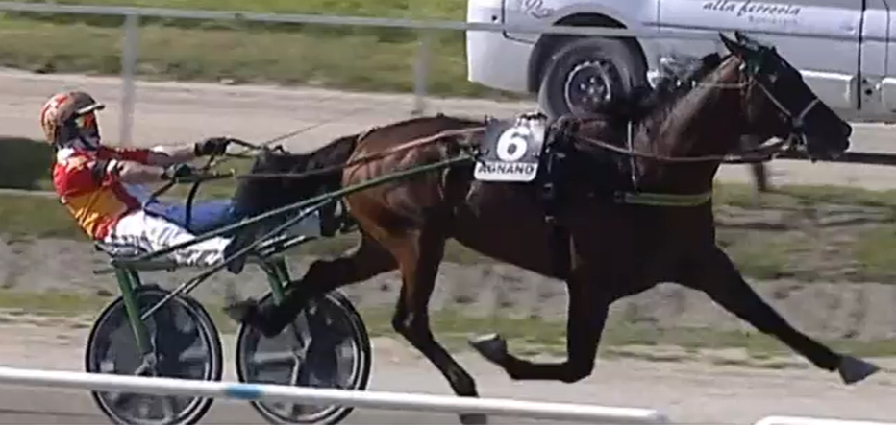Alrajah One
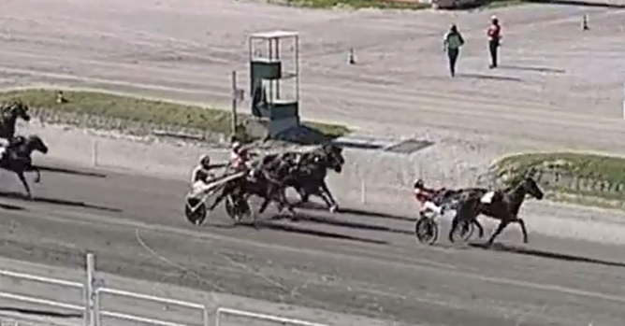
The engaged list for the Lotteria follows along with a Gr. II mares event the same day.
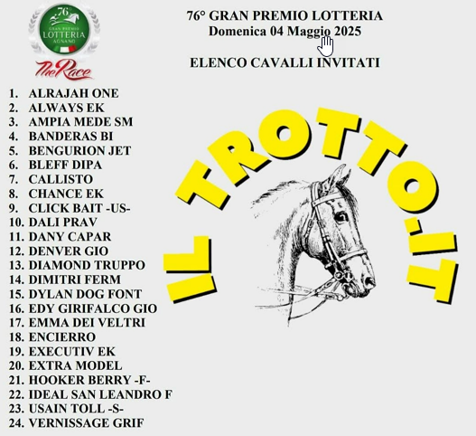
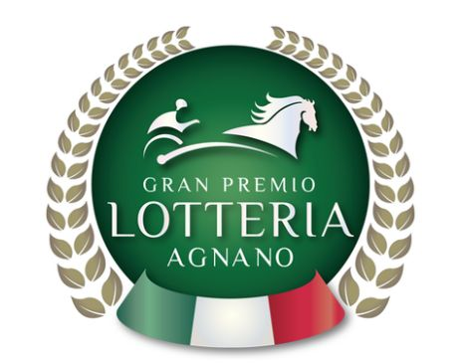
France’s Hooker Berry is on the Lotteria list.
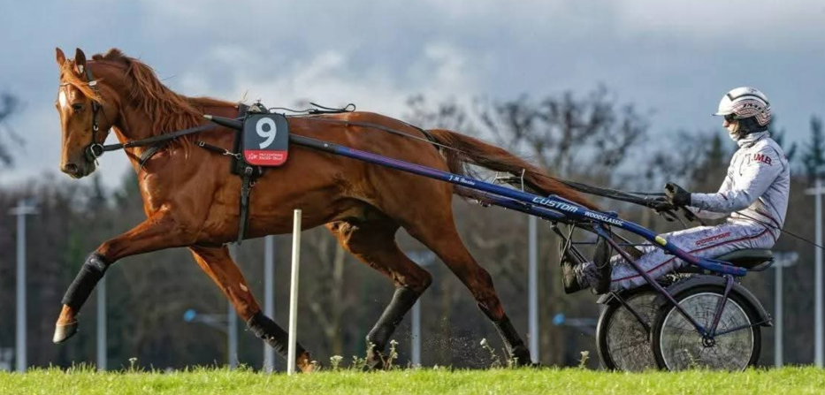Hooker Berry

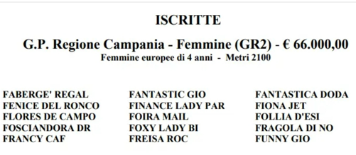
Gaet, Napoli Agnano files/photos
Thomas H. Hicks

