Lasko des Brousses Takes Prix de Dozule
February 1, 2025 Harness Trots France
Lasko des Brousses (4g Quaker Jet-Osaka des Brousses) controlled affairs to win the featured Gr. III monte Pris de Dozule (purse 80,000€, 2700 meters, 12 European four year olds) at Vincennes timed in 1.13.5kr. Off at 2.2/1 odds this Eric Raffin ridden and Jocelyn Robert trained gelding now has three wins in France from 14 starts for 98,175€. This Sandrine Robert owned performer bested the also 2.2/1 odds Lara du Lerre (4f Dollar Macker) handled by jockey Paul Philippe Ploquin for Ecurie FIF and trainer Emmanuel Allard. Third was 103/1 Lotus Zen (4g Booster Winner) with J.Y. Ricard aboard for owner/trainer Martial Dupuis. Monte action this day preps for the Gr. I Prix L’Ile de France on Sunday
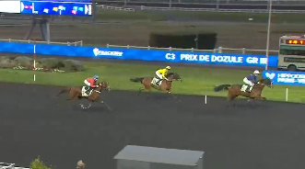Lasko des Brousses
Replay https://www.letrot.com/courses/2025-02-01/7500/3

In the monte Prix Henri Hellard (purse 41,000€, 2700 meters, 18 European six year olds) the 4.2/1 odds Just In Love (6f Love You-Vacate Money-Prodigious) was placed first when the leader on the line was disqualified to last. Eric Raffin was the winning jockey for Ecurie Victoria Dreams and trainer Jean Philippe Dubois. The now three time winner has earned 73,585€. Joyau de Mortree (6g Black Avril) was placed second off at 69/1 with Guillaume Martin in the irons for veteran trainer Franck Leblanc while 61/1 odds Judoka (6m Singalo) was placed third with Marius Durville the jockey for trainer Benoit Carpentier.
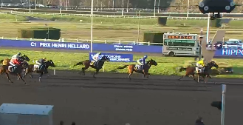Just In Love 2 placed1
Replay https://www.letrot.com/courses/2025-02-01/7500/1

Trotteur Francais, Paris-Vincennes files/photos
Thomas H. Hicks

