Ina du Rib Takes Gr. I Prix de L’Ile de France
February 2, 2025
Joel Hallais’ trained Ina du Rib (7f Uhlan du Val-Tina du Rib) secured today’s Gr. I International Prix de L’Ile de France (Cornulier Races, Gr. I, purse 200,000€, 2175 meters, nine starters ages 4-11) in record time 1.09.6kr (mile rate 1:51.99) over the sprinter distance. The pace was hot from the start with the first 675 meters in 1.05.3kr. The 4.5/1 odds winner now posts eight career victories in 46 starts for 968,660€ earned. J.L. Cl. Dersoir was the jockey and Ecurie Rib owns and bred this mare that today defeated 3/1 Ideale du Chene (7f Bird Parker-Royale du Chene) that Paul Philippe Ploquin handled for trainer Julien Le Mer and breeder/owner Yvonne Guedj. Jean Balthazar (6m Alto de Viette-Dynamite des Vaux) landed third at 10/1 odds with Benjamin Rochard in the irons for trainer Pascal Castel and owner Sandrine Loncke. Completing the top five were 43/1 Hirondelle du Rib (8f Rolling d’Heripre), the winner’s stablemate, with Noe Perron in the irons for Ecurie Rib and trainer Hallais, with fifth to 33/1 Gold Voice (9f Jag de Bellouet) handled by Clement Frecelle for trainer Thomas Levesque and owner/breeder David Benchetrit. A big crowd was on hand today.
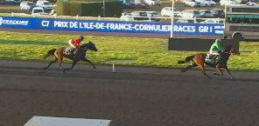Ina du Rib
Replay Replay https://www.letrot.com/courses/2025-02-02/7500/7
Joel Hallais 

The previous time record was 1.10.0kr set by Bilibili in 2020. The recent winners of this classic monte test are shown below.

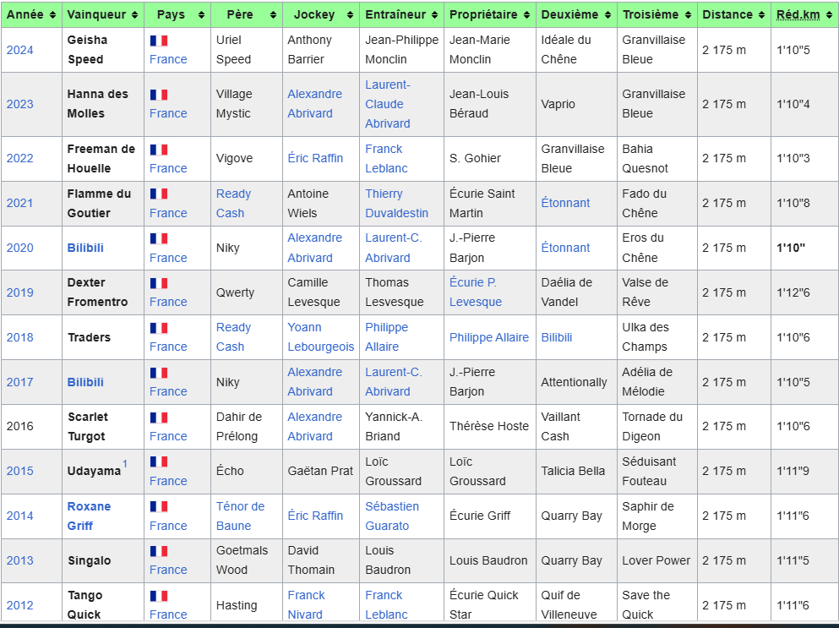
On the undercard was the Prix Leopold Verroken (Gr. III, purse 60,000€, 2175 meters, nine three year old starters) that went to front striding even-money favorite Mille Etoiles (3f Prodigious-Electra Green-Texas Charm) with Jean Michel Bazire teaming the Nicolas Bazire trainee for Scuderia Mistero Srl. This filly was bred by Jean Philippe Dubois and she now sports four career wins in 11 starts for 89,565€. The 22/1 odds Missandei (3f Village Mystic-Fun Lady Black) rallied for second with Benjamin Rochard driving for owner/trainer Antonio Ripoll-Riggio that nosed out third finishing 4.5/1 Mat Manathis (3m Booster Winner) that Eric Raffin reined for Alexis Prat and owner Laurent Broomhead. The 7.3/1 odds Make A Dream (3m Royal Dream) was fourth for owner/trainer/driver Julien Dubois. Jean Philippe Dubois also bred this one.
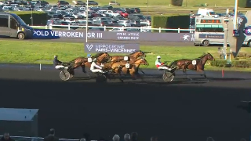Mille Etoiles
Replay https://www.letrot.com/courses/2025-02-02/7500/3

Earlier today the Prix Indienne (monte, purse 71,000€, 2175 meters, nine European starters ages 5-6) went to great gaited Elegance Kronos (5f Muscle Hill-Pampered Winner) ridden by jockey Alexandre Abrivard to his first win in France from two starts. The L.C. Abrivard trainee is owned by Jean Pierre Barjon and now has earned 263.356€. What a pedigree here, the dam is a Credit Winner from Pampered Princess she by Andover Hall-Bold Dreamer. Elegance Kronos is her second of six foals, four of racing age with only two having raced to date. Pampered Winner had a 2-6-1 slate in 23 starts under guidance of Jimmy Takter in the US and Daniel Reden in SWE. Finishing second in today’s race was 4.7/1 Jason du Conroy (6g Booster Winner) and jockey Nathalie Henry followed by third finishing 5.3/1 odds Kerry Love (5f Brillantissime-Amie Love) with trainer Mathieu Mottier aboard. Jus de Fruit (6m Love You-Andalouse) was fourth for Adrien Lamy at 6.5/1 and 7.6/1 Global Etalon (5m Brillantissime-Devilish Yankee) was fifth with Paul Philippe Ploquin in the irons. Elegance Kronos
Replay https://www.letrot.com/courses/2025-02-02/7500/2

In other news the champion Horsy Dream has returned to training toward a hopeful return to the races.

Paris-Vincennes, Trotteur Francais files/photos
Thomas H. Hicks

